We need minimum 100 rpm motor.
Torque calculation: 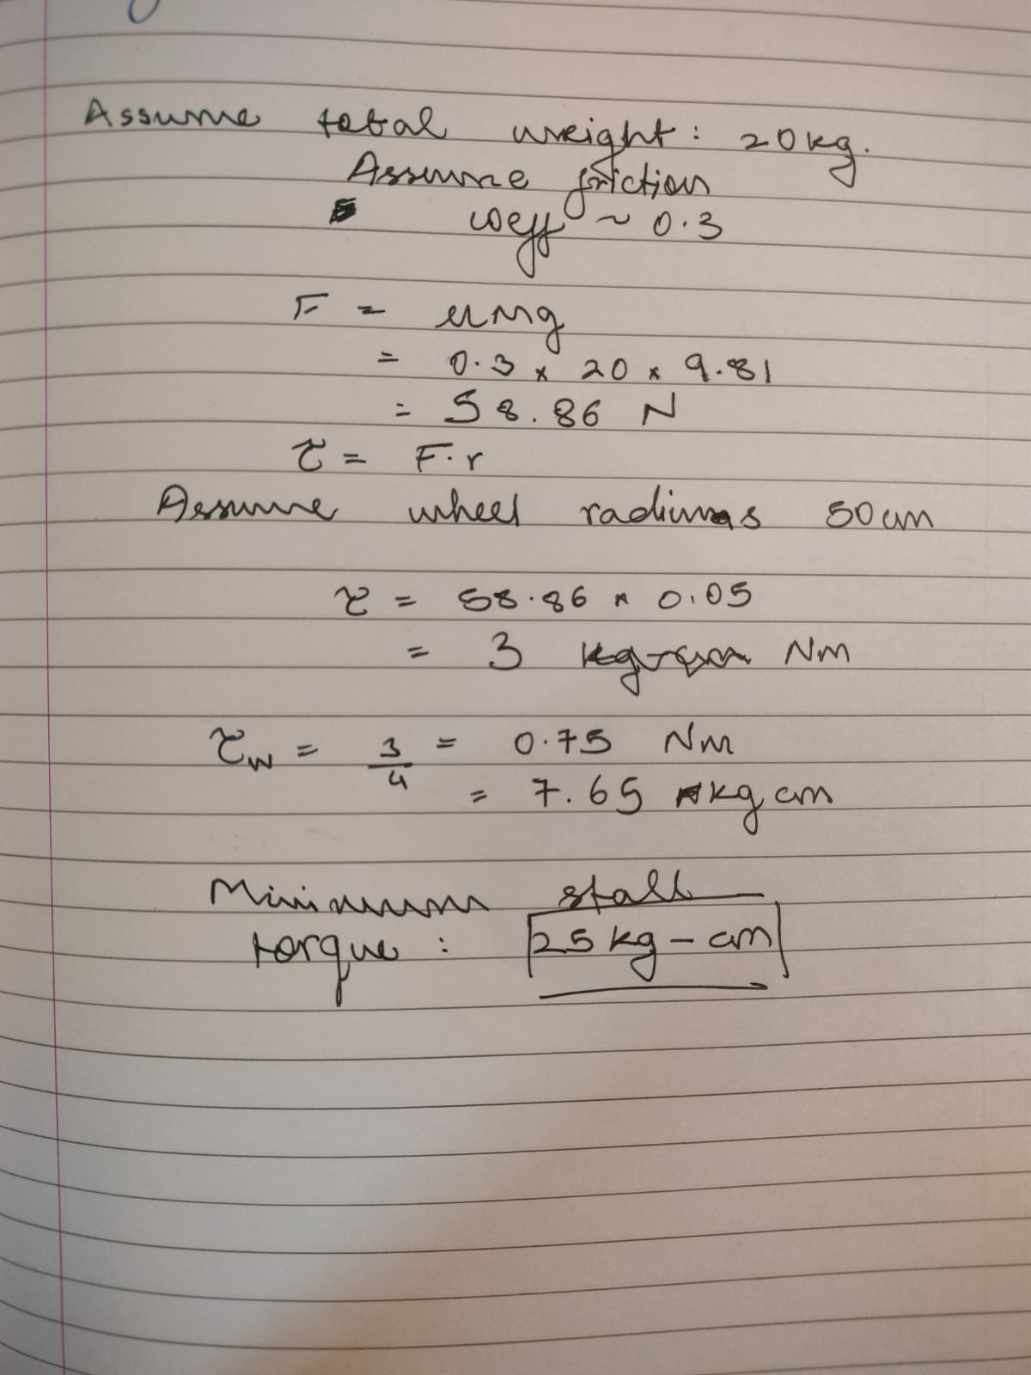
Therefore minimum required torque is 25 kg-cm considering the above assumptions.
Motor Order link:
https://robokits.co.in/motors/dc-motor/12v-high-torque-motor/high-torque-dc-geared-motor/high-torque-12v-dc-geared-motor-100rpm
Brackets:
https://robokits.co.in/motors/dc-motor/mounting-clamps/high-quality-bracket-for-high-torque-side-shaft-motor
For designing the motor and its brackets dimensions and mechanical drawing along with the specification are given on the link provided.

Speed of robot = 0.52m/s

